FACULTY OF MANAGEMENT

SCHOOL OF COMPUTING

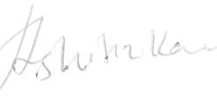

**Certificate of Organizer**

**This is certificate is presented to**

Shreyan Mukherjee

recognizes your outstanding dedication in organizing E-GNITE'24, an Entrepreneurship Talk Show on March 18th, 2024, featuring Ankush R Barjata, Founder of Deeva, and Rupavahini Selvaraj, Associate Director of HCLTech. Your tireless efforts significantly contributed to the event's success, fostering insightful discussions with these esteemed entrepreneurs.